
This article is more than 7 years old
URCA STAPS

L2 MANAGEMENT

SEMESTER 3 (2025-2026)

ENGLISH:
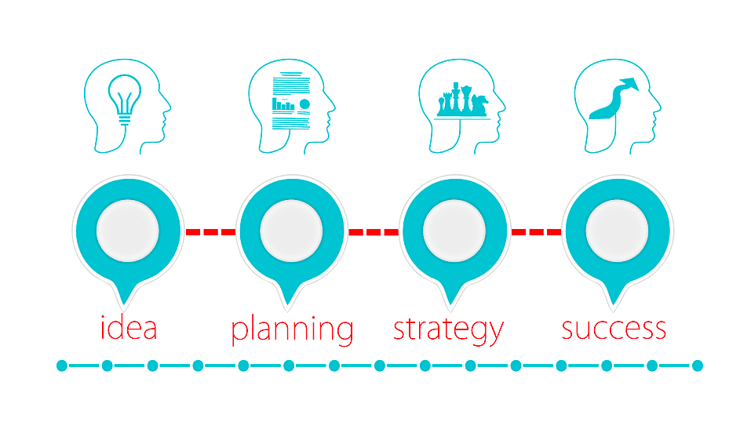

Delphine NOWAKOWSKI

https://www.micrositepro.fr/formations/stapsl2mgt-s1

Table of Contents
1. Introduction to Nike & work on business structures 3
2. Nike’s product and service offering, target segments and promotion 9
3. Nike’s strategy 14

1. Introduction to Nike & work on business structures
Video: Nike presentation 2019
Let’s answer the following questions [0.00:02.03] :
Q1. What has the brand built over time?

Q2. Who founded Nike?
Q3. What did they open in 1966?

Q4. When was the first Nike brand shoe launched?

Q5. What happened in 1980?

Q6. In how many countries did Nike operate at the beginning of the 21st century?
Q7. What is the name of Nike’s logo?

Q8. How did Nike diversify its range of products and activities?

Q9. Please write down the important business names, activities and public figures names you may hear.

Vocabulary:
- a customer base:
- an outlet:
- retail:
- to launch:

Let’s do a bit of research: these are business structures. Can you identify their main characteristics?
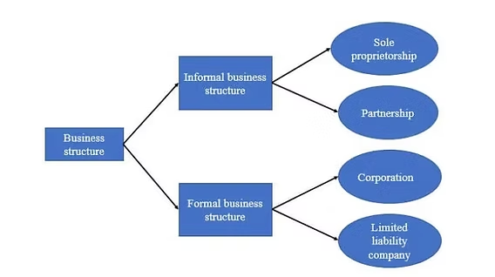

SOLE PROPRIETORSHIP | PARTNERSHIP | CORPORATION | LIMITED LIABILITY COMPANY
In the video, the presenter says Nike went public 2 years later”. What does he mean?

How can a company grow?

Business growth types
(source: https://www.synerion.com/blog/4-types-of-business-growth )

“Growth is the goal of every business. Whether it's moving into a larger venue or taking your product global, creating a vibrant business that produces new products, services, sites, and jobs is the ultimate goal of a business owner. Determining the best way to grow your business takes a strategic plan and a solid understanding of how businesses grow. These 4 types of business growth can help you assess how to best expand your current business.
Organic Business Growth
Organic business growth is the most basic but most effective means of growth for a business. Organic growth focuses on producing more products, services, and space for business success. Businesses who are focusing on organic growth may buy a larger storefront or expand shifts to manufacture more product. Businesses focused on growing organically need to literally expand to accommodate their needs.
Organic growth is a solid business growth strategy for new businesses and also businesses who have tapped into a new market and face shortage of product. Additional space or production meet a growing need among consumers and prevent shortage. Organic business growth is an unsustainable growth strategy but one that ultimately sets a business up for future success.

Strategic Business Growth
Strategic business growth focuses on the long term growth of a business. Businesses who should focus on strategic growth have reached the epoch of their organic business growth stage and need to find additional markets. A strategic growth strategy may be to reach a previously untapped market through advertising or create additional products to add to inventory. Strategic business growth requires the money generated by organic growth because businesses won't experience that same watershed business acceleration. Instead, it will be a gradual increase in sales.
Strategic growth is an essential stage for businesses that have plateaued. The strategic business growth strategy allows businesses to focus on long-term plans and use stored capital to attain those goals. Strategic growth is difficult for new businesses or businesses who are producing less product than is in demand. Ultimately, strategic business growth is a great strategy to tap when looking at long term business planning.

Partnership/Merger/Acquisition
For some businesses, acquiring, merging, or creating a partnership with another business can present some unique benefits and opportunities for market expansion. This strategy of business growth is the riskiest but also with the most potential success. A well laid merger or acquisition can help a business enter a new market, manufacture more product, and gain the customer loyalty cultivated by another brand.

Internal Business Growth
Internal business growth is both the easiest and hardest way to promote business growth. Rather than looking outward to production, this business growth strategy uses current resources and determines how they can be used better. Internal growth would include a business implementing lean systems or automated workforce management systems. This growth is often the hardest because rather than simply expanding into another market or trying to expand a product line, businesses must change how they conduct business, a process that can be scary to employees and managers.
In times between strategic and organic growth, internal business growth is a great way to maximize resources without a significant outlay of capital. In fact, internal growth should allow a business to continue production using less resources, recouping any costs spent maximizing processes. Internal business growth is a practical business growth strategy during any "lull" in outward growth.

Vocabulary:
- organic (business growth):
- a shift:
- to tap into:
- shortage:
- epoch:
-additional:
- watershed:
- to plateau:
- demand:
- a merger:
- to merge:
- customer loyalty:*
- to implement:
- a lean system:
- automated workforce management system:
- significant:
- outlay:
- to recoup:
- lull:

Let’s answer the following question: what path(s) has Nike followed in terms of business growth?

-----

Now please Work on your assignment:

Please select the business / organisation you will work on and gather the key elements relating to its history and development

2. Nike’s product and service offering, target segments and promotion
Video: Nike presentation 2019 |  | BRAINSTORMING
Presentation of Nike’s products & services [02.04:03.54] :
What do you feel while watching this presentation of Nike’s products and services?
Tip: where does the Air Force 1 fit? What about your favourite Nike product?

Presentation of Nike’s 3 target segments [03.55:06.45] :
Q1. What is Nike about, rather than just its products?
WOMEN:
Q2. What specific women’s apparel has Nike expanded?

Q3. How did women’s sales grow in the last quarter?
Compared to men’s?:

Q4. What is the athleisure trend about?

Q5. How much could women’s line add year to year?

YOUTH
Q6. How does Nike get youngsters to wear its products?

Q7. What other means are successful to attract the young people?

Q8. What champions, what sports are quoted here?

RUNNING
Q9. Is the running segment performing as well as the other 2 previous segments? Does it fulfill Nike’s expectations?

Q10. What is special about this segment?

Vocabulary:
- apparel:
- double digit figure
- to outpace;
- a trend:
- to run errands:
- brunch:
- currency:
- figures:
- youngster:
- to draw:
- to fulfill expectations:
- to grow:
- to remain:
- to revamp:

Note: for more info on Nike’s target market see https://businessmodelanalyst.com/nike-target-market/

Video: Nike presentation 2019 |  | BRAINSTORMING

Nike’s promotion [06:48:08:27] :
Summarize what you understand about Nike’s marketing campaigns.
Unstoppable Together:

Be like Mike:


Research Nike’s Promotion: slogans, the Swoosh & Nike’s visual identity

3. Nike’s strategy
Video: Nike presentation 2019 |  | BRAINSTORMING
Presentation of the conclusions on Nike [08.28:END] :
Please write down a summary of the conclusions on Nike’s presentation.

Analysis:
What is unique in this presentation? What is specific about Nike?

Nike Mission and Vision Statement Analysis
(source: https://boardmix.com/analysis/nike-mission-and-vision-statement-analysis/)

In the realm of sports apparel, Nike stands as an unparalleled titan. The iconic Swoosh logo has become a symbol of quality, endurance, and athletic superiority, imprinted on sports gear donned by both the budding novice and the professional athlete. However, the magic of Nike lies far beyond its cutting-edge technology and stylish designs. At its heart, Nike's mission, vision, and core values serve as a compass, directing every initiative and driving every endeavor.

Nike’s MISSION Statement

Delving deeper into Nike's mission statement, "Bring inspiration and innovation to every athlete* in the world," it's clear that Nike's ambition extends far beyond merely dominating the global sports apparel market. This statement is a testament to Nike's intent to not only serve but inspire and revolutionize the experience of every athlete across the globe.
Let's dissect this statement to grasp its full import.

“Bring Inspiration...”
When Nike states its mission to "Bring Inspiration," it places the psychological facet of sports at the forefront. The company believes that the inspiration to challenge one's limits, strive for personal bests, and stay motivated even in the face of defeat, is just as important as physical training for any athlete.
Nike endeavors to be the source of this inspiration. Be it through their innovative product range designed to enhance performance, their compelling ad campaigns that highlight the journeys of perseverance and success, or their partnerships with high-performing athletes who serve as role models for millions worldwide. Each of these channels aims to ignite a spark within every individual who engages with Nike in any way, thereby reinforcing a positive association with sports and physical activities.

“…and Innovation…”
Innovation forms the cornerstone of Nike's ethos. By weaving this into its mission statement, Nike is voicing its dedication towards constant technological advancements and design breakthroughs that redefine what sports gear can achieve.
This pursuit of innovation finds expression in Nike's products, which often go beyond market expectations and set new benchmarks for competitors. Whether it is about developing new materials that enhance durability while reducing environmental impact, designing wearables that offer insights into performance metrics, or launching footwear customized for specific sports or athlete needs - innovation is the common thread running through all of Nike's initiatives.

“…to Every Athlete in the World*”
The use of an asterisk in their mission statement serves to redefine the word 'athlete'. According to Nike's co-founder Bill Bowerman, "If you have a body, you are an athlete". This is a powerful declaration that challenges conventional perceptions and democratizes sports.
Nike’s mission does not discriminate between a professional sprinter and someone jogging around their local park, between an Olympic gymnast and a child in gymnastics class, between a high-profile basketball player and a wheelchair athlete playing on a community court. For Nike, all of them are athletes.
By vowing to reach every athlete 'in the world', Nike emphasizes its global presence and underscores its commitment to cater to diverse needs across different regions, cultures, and socio-economic classes.
Nike's mission statement lays bare the brand's commitment to inspire individuals towards athleticism, continuously innovate to enhance athletic performance, and bring these benefits to every person around the world - thus standing as an inclusive brand for all who dare to dream and strive to achieve.

Nike’s VISION statement
Nike's vision statement: "to do everything possible to expand human potential." It underscores the brand's dedication towards enhancing human capability through the power of sports. This statement articulates a vision far-reaching in its scope, affirming Nike's position as not just a sports apparel brand but a facilitator of human potential. Here's a deeper exploration of this vision statement.

To do everything possible
This phrase asserts Nike’s commitment to going above and beyond in realizing its vision. The emphasis on 'doing everything possible' suggests a relentless pursuit, regardless of challenges or obstacles that may arise.
The statement reflects the spirit of determination and perseverance intrinsic to sportsmanship, embodying the same level of grit and tenacity expected of the athletes that Nike caters to.

To expand human potential
At the heart of Nike's vision is the expansion of 'human potential'. The company seeks to enable individuals to transcend their physical and mental boundaries and achieve unprecedented levels of performance.
The focus is not limited to enhancing athletic prowess; it extends to fostering personal growth, encouraging individual aspirations, and building self-confidence. Nike, therefore, positions itself as a catalyst for personal progress and empowerment.

Through the provision of modern sports apparel
The tool through which Nike aims to achieve this vision is the 'provision of modern sports apparel'. With its constant innovations in design and technology, Nike seeks to provide products that enhance performance, maximize comfort, and inspire confidence in every athlete.
Nike’s emphasis on 'modern' reflects its commitment to staying abreast with current trends, emerging technologies, and evolving consumer needs. This ensures that Nike products aren’t just fashion-forward, but also at the cutting edge of technological advancements in sportswear.

Designed to aid athletes of all abilities
Nike's vision doesn't discriminate between professional athletes and fitness enthusiasts. By stating "athletes of all abilities," Nike underlines its commitment to inclusivity, offering products tailored to various skill levels, physical capabilities, and athletic pursuits.
This ensures that everyone, from a budding young athlete to a seasoned marathon runner, can benefit from Nike's innovative product range. In doing so, Nike stands as a brand for all — fueling the spirit of athleticism irrespective of one's starting point.

Vocabulary:
- realm:
- cutting-edge:
- to delve:
- mission statement:
- merely:
- to grasp:
- to endeavour (endeavor):
- to enhance:
- compelling:
- an ad campaign:
- to highlight:
- to ignite:
- a spark:
- to engage with:
- thereby:
- cornerstone;
- ethos:
- to weave:
- dedication:
- a breakthrough:
- benchmark:
- thread:
- to vow:
- to emphasize:
- to underscore:
- commitment:
- to cater:
- “lays bare the brand’s commitment:
- thus:
- to strive:
- to achieve:
- vision:
- to far-reach:
- scope:
- to assert:
- relentless:
- pursuit:
- grit:
- a boundary:
- prowess:
- to foster:
- to stay abreast:
- current:*

- a trend:
- budding:
- seasoned:

Please:

1. Summarize Nike’s mission statement

2. Summarize Nike’s vision statement

3. Analyse: what is the difference between the mission and the vision statements?

